Aim: Demonstrate Data Validation

Code:

<!doctype html>
<html lang="en">
<head>
<meta charset="utf-8" />
<meta name="viewport" content="width=device-width,initial-scale=1" />
<title>Login / Signup</title>
</head>
<body>
<main class="container">
<section>
<div class="card">
<div class="tabs" role="tablist" aria-label="Auth tabs">
<button
id="tab-login"
class="active"
role="tab"
aria-selected="true">
Login
</button>
<button
id="tab-signup"
role="tab"
aria-selected="false">
Sign up
</button>
</div>

<div id="login-panel">
<form id="login-form" novalidate>
<div>
<label for="login-identifier">Email or Username</label>
<input
id="login-identifier"
name="identifier"
type="text"
required
placeholder="you@example.com or username"
/>
<div
class="error"
id="login-identifier-error"
></div>
</div>

<div>
<label for="login-password">Password</label>
<div class="field-inline">
<input
id="login-password"
name="password"
type="password"
required
placeholder="Enter password"
/>
<button
type="button"
class="toggle-pass"
data-target="login-password">
Show
</button>
</div>
<div
class="error"
id="login-password-error"
></div>
</div>

<div class="actions">
<div class="small helper">
Forgot password? Click reset on server.
</div>
<button class="btn" type="submit">Login</button>
</div>
<div
id="login-feedback"
class="muted"
role="status"
></div>
</form>
</div>

<div id="signup-panel" style="display: none">
<form id="signup-form" novalidate>
<div>
<label for="username">Username</label>
<input
id="username"
name="username"
type="text"
required
placeholder="username (3–20 chars)"
/>
<div class="error" id="username-error"></div>
</div>

<div>
<label for="email">Email</label>
<input
id="email"
name="email"
type="email"
required
placeholder="you@example.com"
/>
<div class="error" id="email-error"></div>
</div>

<div class="row">
<div class="col">
<label for="phone">Phone</label>
<input
id="phone"
name="phone"
type="tel"
placeholder="+1234567890"
/>
<div class="error" id="phone-error"></div>
</div>
<div class="col">
<label for="dob">Date of birth</label>
<input
id="dob"
name="dob"
type="date"
required
/>
<div class="error" id="dob-error"></div>
</div>
</div>

<div>
<label for="password">Password</label>
<div class="field-inline">
<input
id="password"
name="password"
type="password"
required
placeholder="Minimum 8 characters"
/>
<button
type="button"
class="toggle-pass"
data-target="password">
Show
</button>
</div>
<div class="error" id="password-error"></div>
</div>

<div>
<label for="confirm-password">Confirm password</label>
<input
id="confirm-password"
name="confirmPassword"
type="password"
required
/>
<div
class="error"
id="confirm-password-error"
></div>
</div>

<div>
<label><input id="terms" type="checkbox" /> I agree to the terms and privacy policy</label>
<div class="error" id="terms-error"></div>
</div>

<div class="actions">
<button class="btn" type="submit">
Create account
</button>
<button
type="button"
class="btn ghost"
id="fill-sample">
Fill sample
</button>
</div>
<div id="signup-feedback" role="status"></div>
</form>
</div>
</div>
</section>
</main>

<script>
const qs = (s) => document.querySelector(s);
const qsa = (s) => document.querySelectorAll(s);

const tabLogin = qs("#tab-login");
const tabSignup = qs("#tab-signup");
const loginPanel = qs("#login-panel");
const signupPanel = qs("#signup-panel");

function showPanel(panel) {
if (panel === "login") {
tabLogin.classList.add("active");
tabLogin.setAttribute("aria-selected", "true");
tabSignup.classList.remove("active");
tabSignup.setAttribute("aria-selected", "false");
loginPanel.style.display = "block";
signupPanel.style.display = "none";
} else {
tabSignup.classList.add("active");
tabSignup.setAttribute("aria-selected", "true");
tabLogin.classList.remove("active");
tabLogin.setAttribute("aria-selected", "false");
loginPanel.style.display = "none";
signupPanel.style.display = "block";
} }

tabLogin.addEventListener("click", () => showPanel("login"));
tabSignup.addEventListener("click", () => showPanel("signup"));

qsa(".toggle-pass").forEach((btn) =>
btn.addEventListener("click", (e) => {
const id = btn.dataset.target;
const el = qs("#" + id);
if (!el) return;
if (el.type === "password") {
el.type = "text";
btn.textContent = "Hide";
} else {
el.type = "password";
btn.textContent = "Show";
} }), );

const validators = {
username: (v) =>
/^[A-Za-z0-9_]{3,20}$/.test(v) ||
"3–20 chars; letters, numbers, underscore only",
email: (v) =>
/^[^\s@]+@[^\s@]+\.[^\s@]+$/.test(v) ||
"Enter a valid email",
phone: (v) =>
v.trim() === "" ||
/^\+?\d{10,15}$/.test(v) ||
"Enter 10–15 digits, optional +",
password: (v) =>
(v.length >= 8 &&
/[a-z]/.test(v) &&
/[A-Z]/.test(v) &&
/\d/.test(v)) ||
"Min 8 chars with upper, lower and number",
confirmPassword: (v, all) =>
v === all.password || "Passwords do not match",
dob: (v) => {
if (!v) return "Date of birth is required";
const dob = new Date(v);
if (Number.isNaN(dob)) return "Invalid date";
const today = new Date();
const age =
today.getFullYear() -
dob.getFullYear() -
(today <
new Date(
dob.getFullYear() +
(today.getFullYear() - dob.getFullYear()),
dob.getMonth(),
dob.getDate(),
)
? 1
: 0);
return age >= 13 || "You must be at least 13 years old";
},
terms: (v) => v === true || "You must accept terms",
};

function showError(id, msg) {
const el = qs("#" + id + "-error");
if (!el) return;
el.textContent =
msg === true || msg === false || !msg ? "" : msg;
}

function validateForm(data, rules) {
let ok = true;
for (const key in rules) {
const rule = rules[key];
const value = data[key];
const res =
rule.length > 1 ? rule(value, data) : rule(value);
if (res !== true) {
ok = false;
showError(key, res);
} else {
showError(key, "");
} }
return ok;
}

const signupForm = qs("#signup-form");
signupForm.addEventListener("submit", (e) => {
e.preventDefault();
const data = {
username: qs("#username").value.trim(),
email: qs("#email").value.trim(),
phone: qs("#phone").value.trim(),
dob: qs("#dob").value,
password: qs("#password").value,
confirmPassword: qs("#confirm-password").value,
terms: qs("#terms").checked,
};

const rules = {
username: (v) => validators.username(v),
email: (v) => validators.email(v),
phone: (v) => validators.phone(v),
dob: (v) => validators.dob(v),
password: (v) => validators.password(v),
confirmPassword: (v, all) =>
validators.confirmPassword(v, all),
terms: (v) => validators.terms(v),
};

const valid = validateForm(data, rules);
const feedback = qs("#signup-feedback");

if (!valid) {
feedback.textContent = "Please fix errors above.";
feedback.className = "error";
return;
}

feedback.textContent = "Account created successfully (demo).";
feedback.className = "success";
signupForm.reset();
});

const loginForm = qs("#login-form");
loginForm.addEventListener("submit", (e) => {
e.preventDefault();

const identifier = qs("#login-identifier").value.trim();
const password = qs("#login-password").value;

let ok = true;

if (!identifier) {
showError("login-identifier", "Enter email or username");
ok = false;
} else {
showError("login-identifier", "");
}

if (!password) {
showError("login-password", "Enter password");
ok = false;
} else {
showError("login-password", "");
}

const fb = qs("#login-feedback");

if (!ok) {
fb.textContent = "Please fix errors above.";
fb.className = "error";
return;
}

fb.textContent = "Logged in (demo).";
fb.className = "success";
loginForm.reset();
});

qs("#fill-sample").addEventListener("click", () => {
qs("#username").value = "demo_user";
qs("#email").value = "demo@example.com";
qs("#phone").value = "+12345678901";

const d = new Date();
d.setFullYear(d.getFullYear() - 20);

qs("#dob").value = d.toISOString().slice(0, 10);
qs("#password").value = "Password1";
qs("#confirm-password").value = "Password1";
qs("#terms").checked = true;
});

qsa("input").forEach((input) => {
input.addEventListener("input", () => {
const id = input.id.replace(/-(.+)/, "");
const err = input.getAttribute("aria-describedby");
if (id) showError(input.id.replace(/-error$/, ""), "");
});
});
</script>
</body>
</html>

Output:
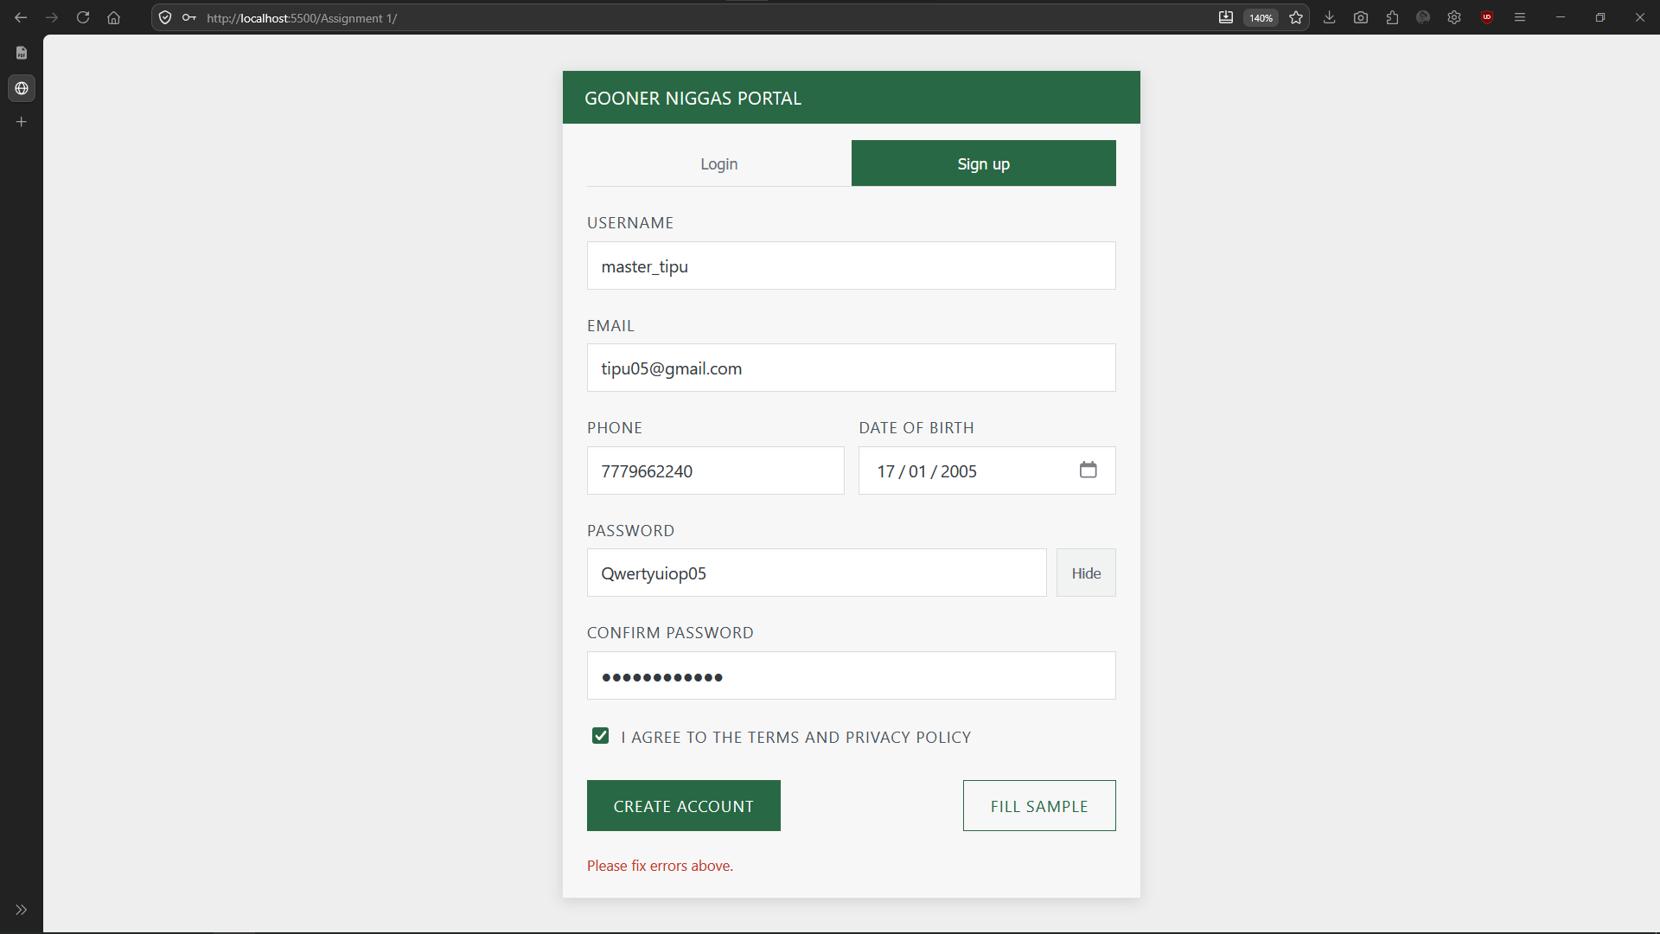
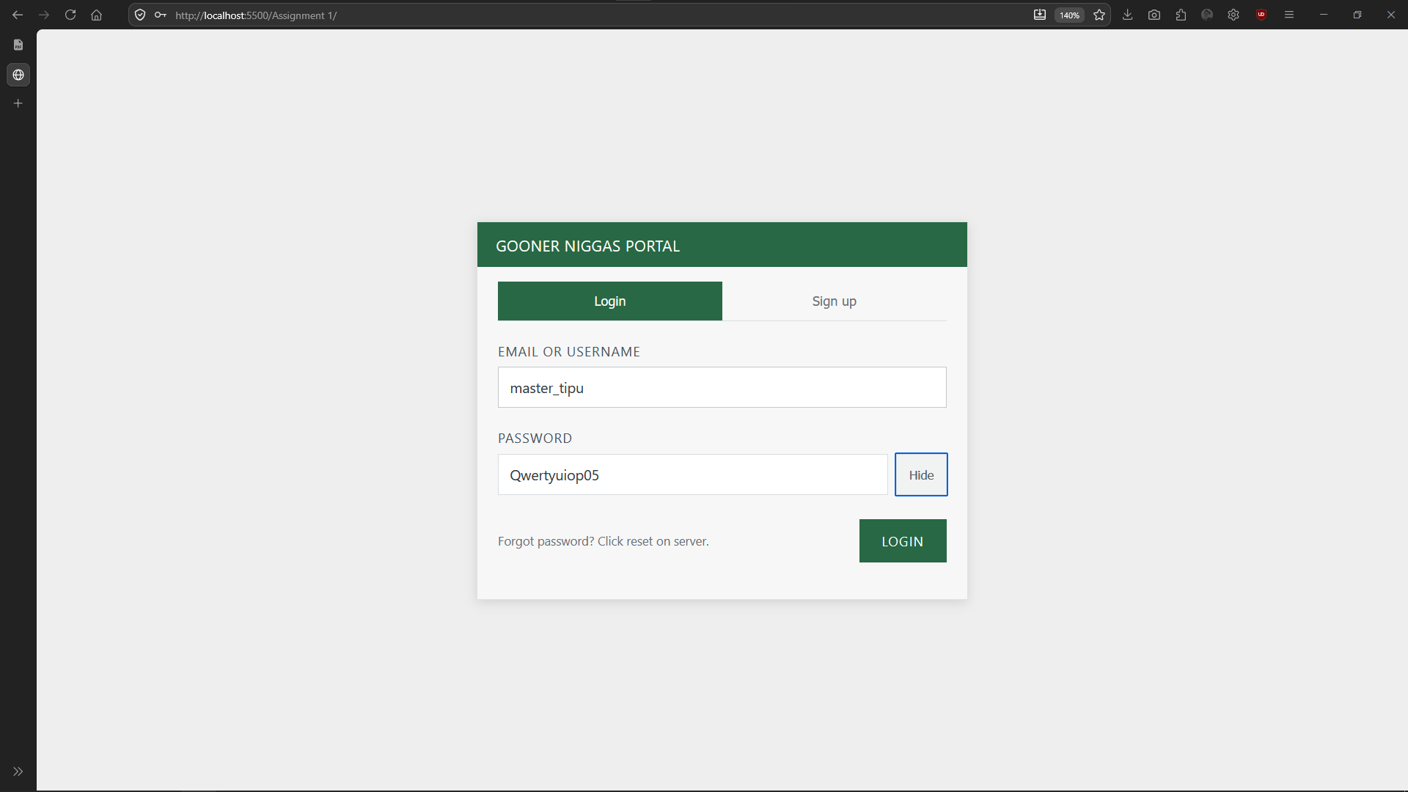

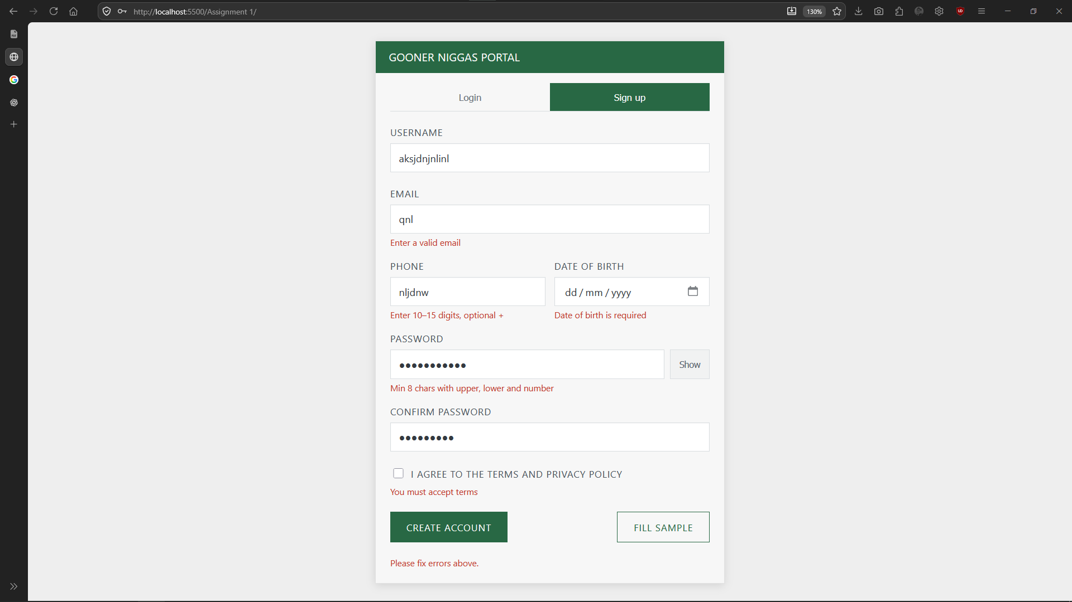

Conclusion:
The program successfully demonstrates data validation by checking user inputs and displaying appropriate error messages before allowing login or account creation.

